Kinney County

Grant Development Survey

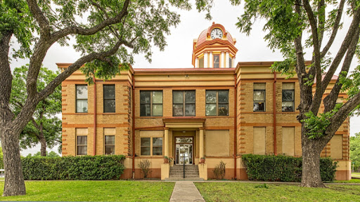

Survey available on Kinney County Website | City of Brackettville, Office | Kinney County Courthouse, Judge’s Office | Request survey via email to grants@co.kinney.tx.us |Return by November 15, 2021
Kinney County held a public hearing on grant development applications, October 25, 2021, 6 PM in the District Courtroom of the County Courthouse. The purpose of the meeting was to allow citizens an opportunity to review and discuss the citizen participation plan, the development of local housing and community development needs, available funding, eligible activities, pending grant activities, and the use of past funds. To gain additional public input, Kinney County would like to request citizen participation through survey completion. The survey will assist Kinney County in planning activities regarding the submission of grant applications throughout the budget year 2021-2022.

Return survey via email to grants@co.kinney.tx.us or drop off at the County Courthouse, Judge’s Office; or City of Brackettville, Office

Contact:  Candy Hobbs via email  grants@co.kinney.tx.us  For a pdf copy of survey | Contact:  Candy Hobbs via email  grants@co.kinney.tx.us  For a pdf copy of survey | Contact:  Candy Hobbs via email  grants@co.kinney.tx.us  For a pdf copy of survey | Contact:  Candy Hobbs via email  grants@co.kinney.tx.us  For a pdf copy of survey | Contact:  Candy Hobbs via email  grants@co.kinney.tx.us  For a pdf copy of survey | Contact:  Candy Hobbs via email  grants@co.kinney.tx.us  For a pdf copy of survey | Contact:  Candy Hobbs via email  grants@co.kinney.tx.us  For a pdf copy of survey

